# NextGen Organics - Complete Ecosystem Walkthrough

**Brief & Technical Overview**

Executive Summary

NextGen Organics is a comprehensive farm-to-table platform combining a frictionless consumer mobile app with a powerful backend administration system. Our dual-model approach ("Hub Store" for speed, "Farms" for transparency) addresses the two biggest market needs: convenience and trust.

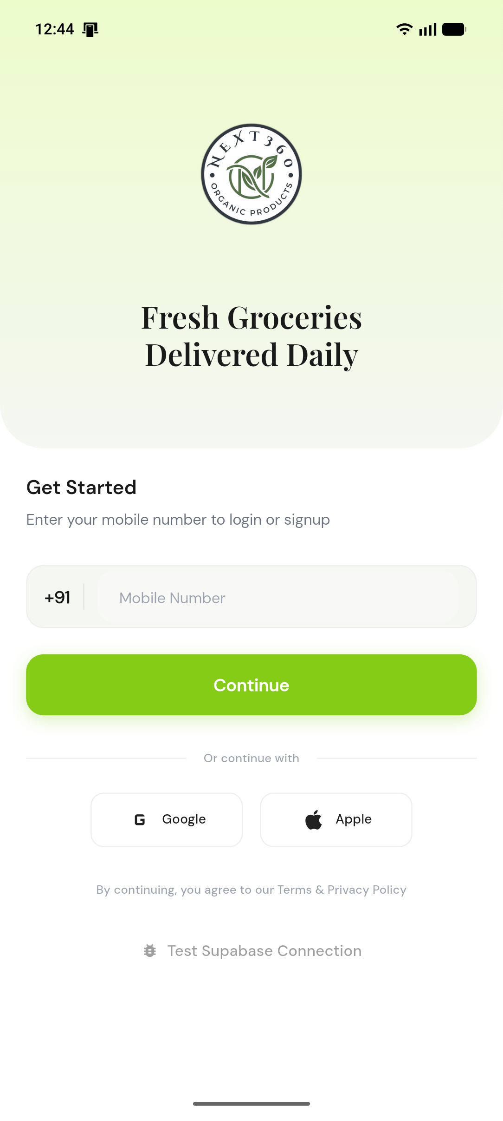

## Section 1: Mobile App (User Journey)

_Focus: Simplicity, Transparency, and Conversion_

### 1. Smart Home Dashboard

**The Command Center**

The entry point focuses on ease of access. Users can search, browse categories, or use our proprietary **Hub/Farms Toggle**.

* **User Sees**: Search bar, Toggle, Category Grid.
* **Action**: Toggles between "Hub Store" (Instant) and "Farms" (Direct).
* **Next**: User selects "Farms" to find local growers.

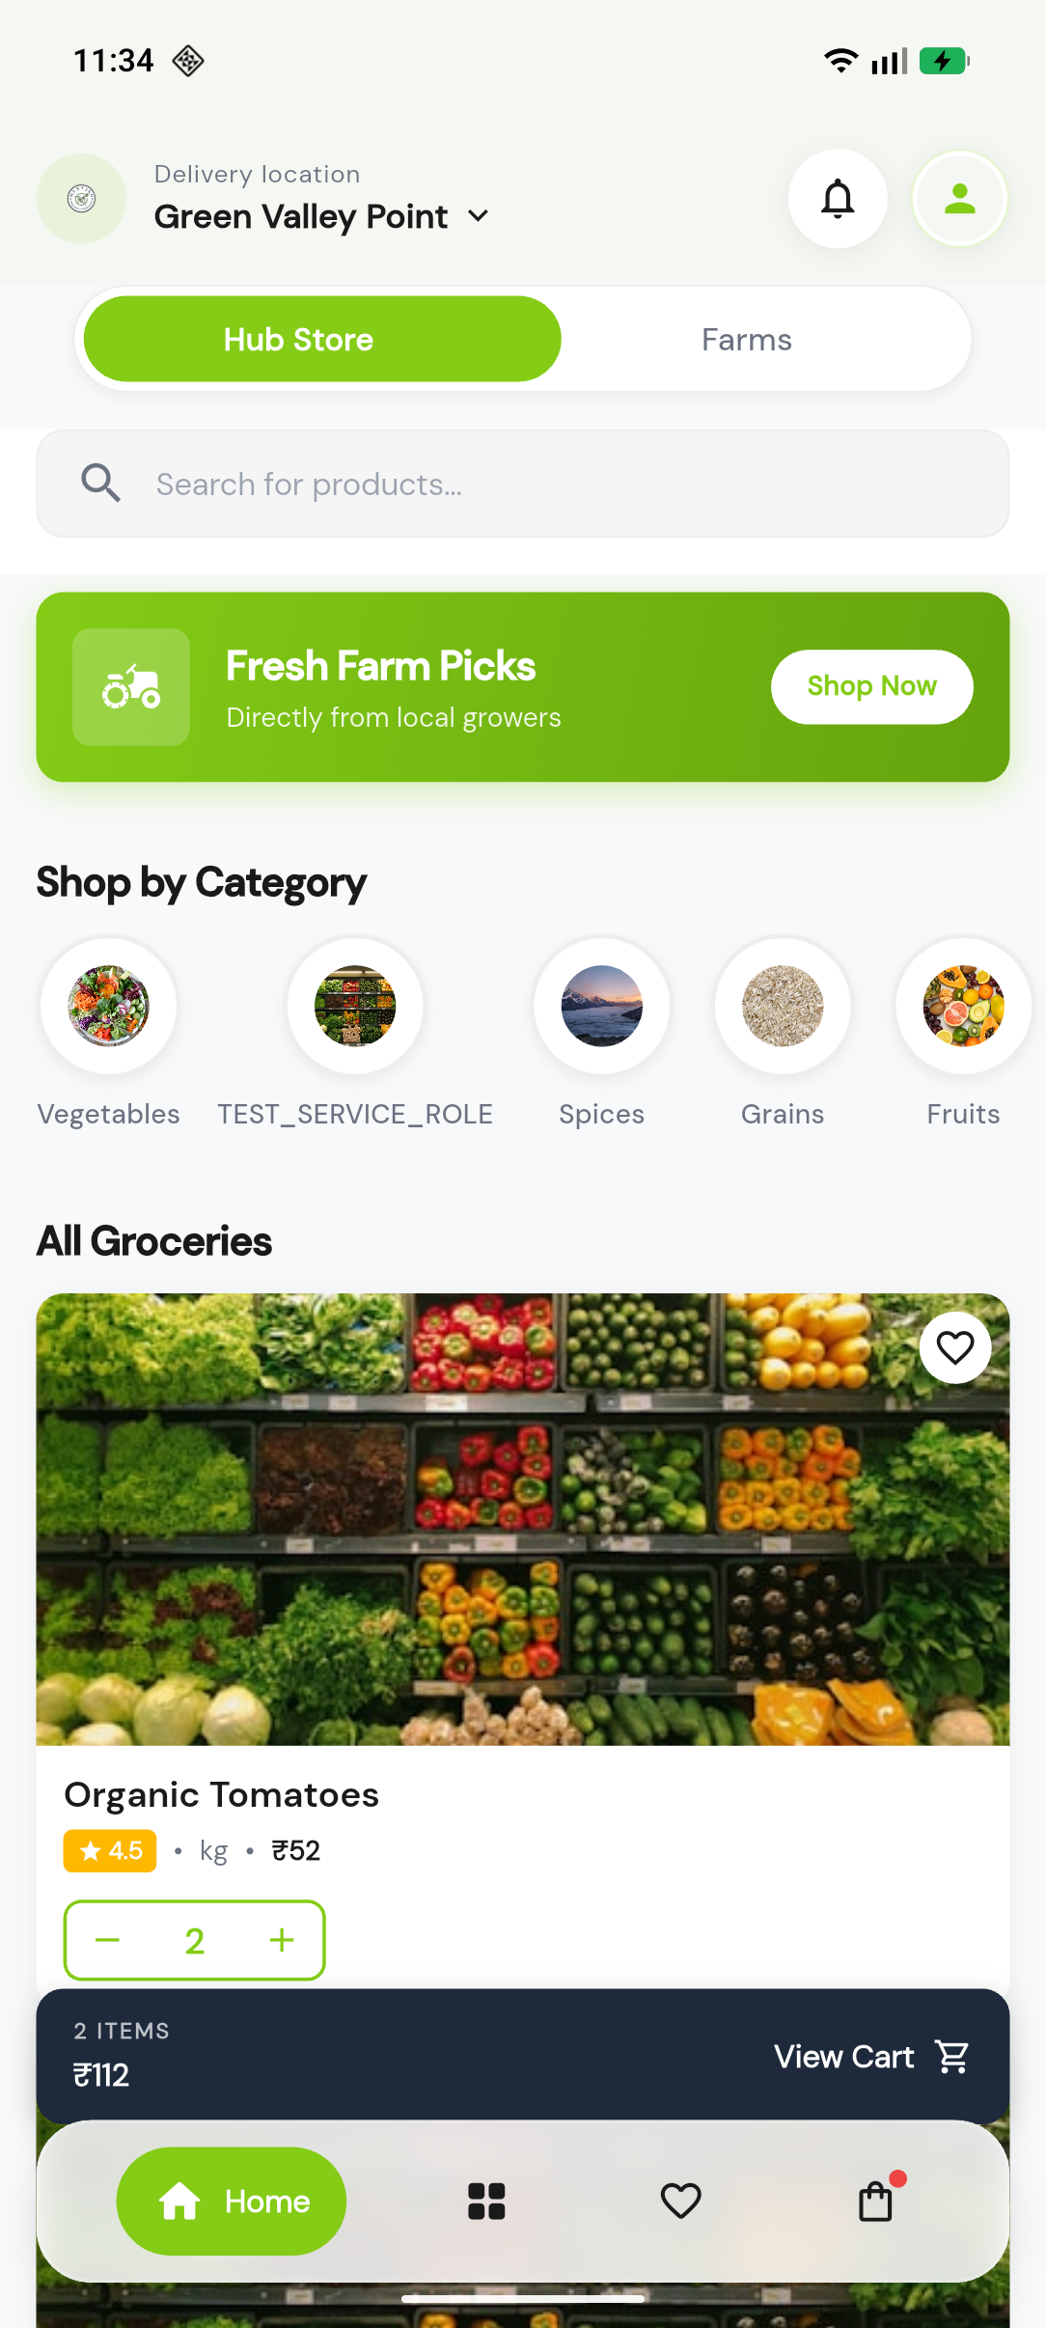

### 2. Farms Directory (Direct Sourcing)

**Transparency First**

This view replaces products with **Vendors**. It is a directory of verified local farms, building trust by showing _who_ is selling.

* **User Sees**: List of verified farms with ratings and location.
* **Action**: Clicks on a specific farm card.
* **Next**: Opens the dedicated vendor storefront.

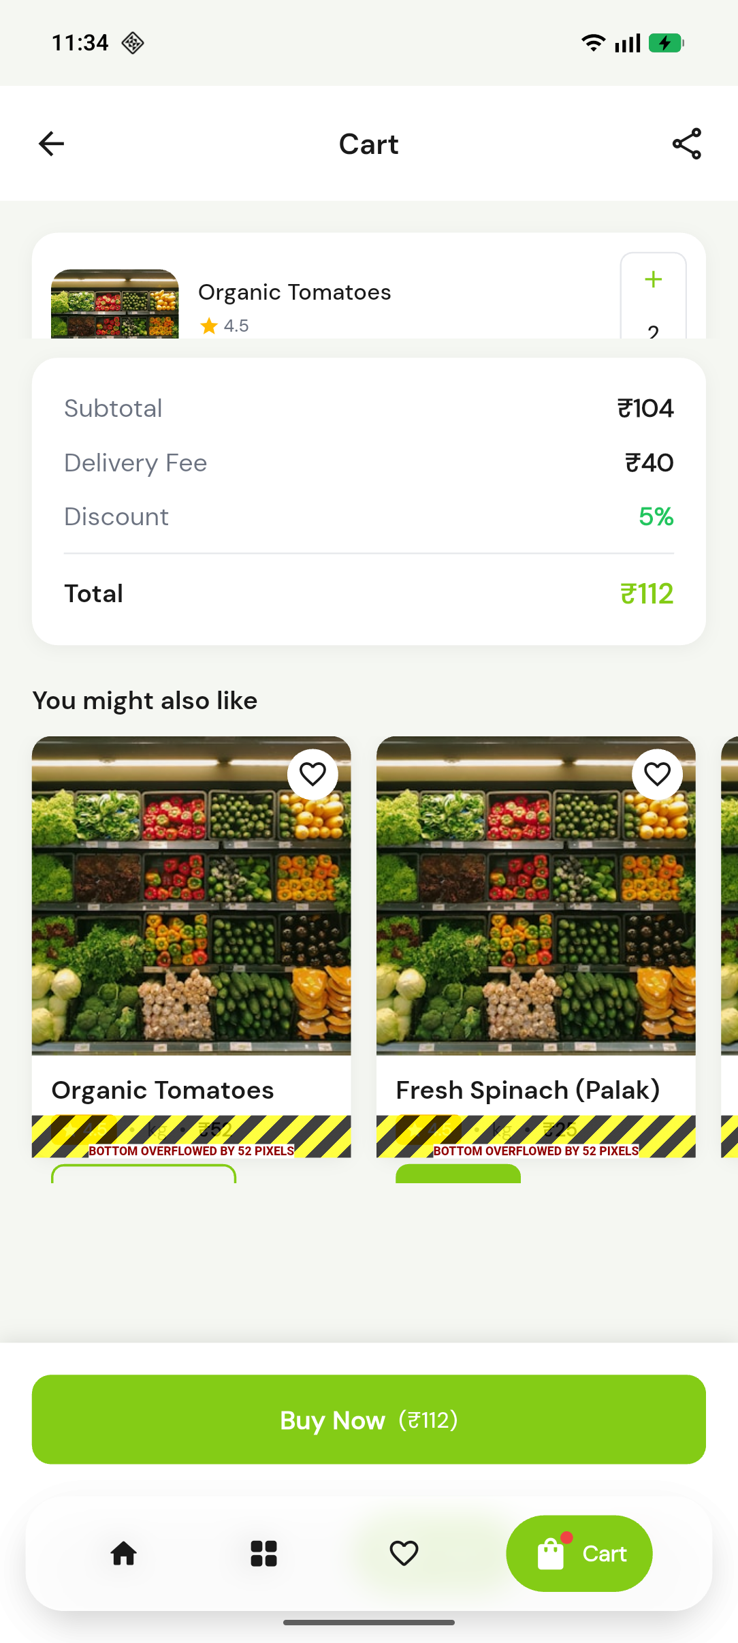

### 3. Vendor Storefront

**The "Zomato" for Farms**

Each vendor gets a dedicated profile page. This digital storefront allows farmers to brand themselves and list their specific inventory.

* **User Sees**: Farm details, hero image, exclusive product list.
* **Action**: Selects a product to view details.
* **Next**: Navigates to product details.

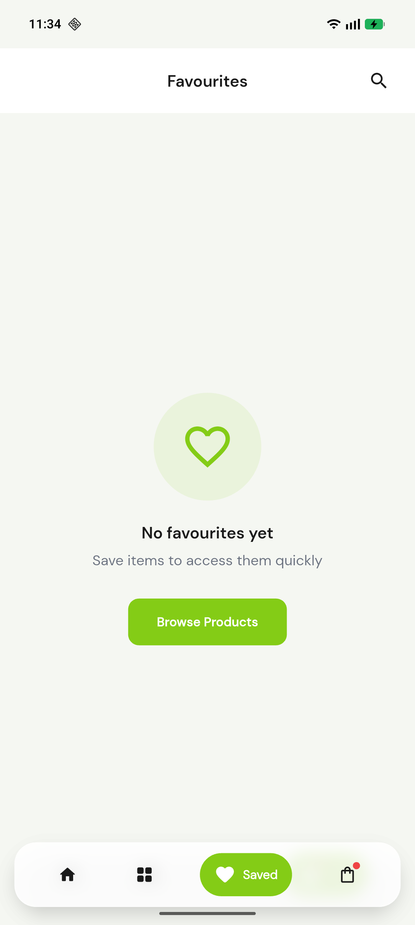

### 4. Product Details & Discovery

**Informed Purchasing**

High-fidelity product pages drive conversion. The **Suggestion Engine** keeps users engaged by showing "More from this Farm".

* **User Sees**: Price per unit, origin, related farm products.
* **Action**: Adds item to cart.
* **Next**: Moves to checkout.

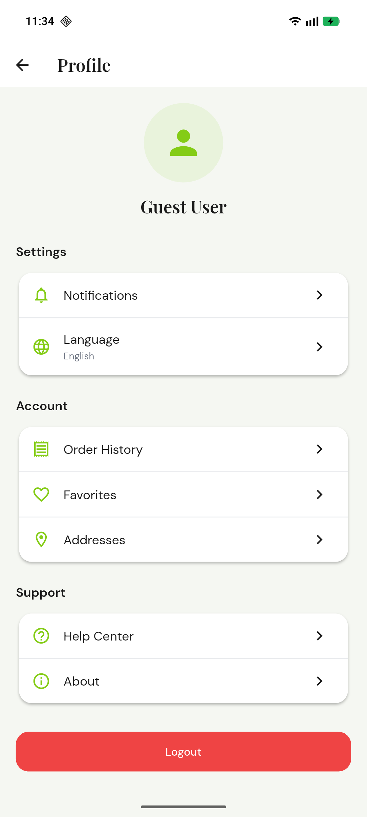

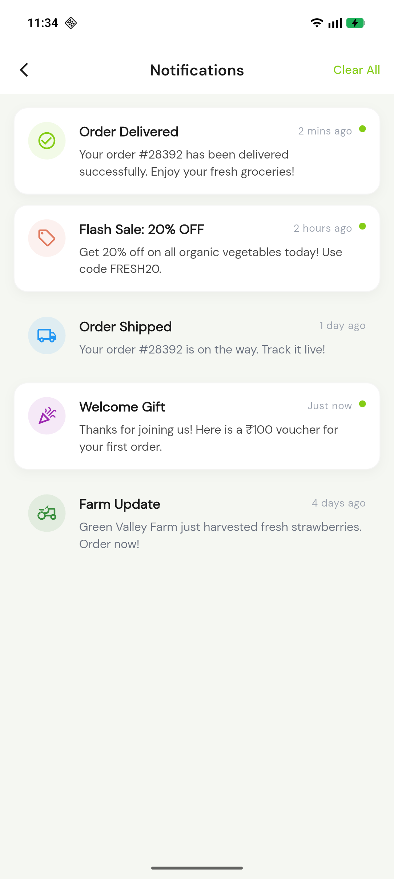

### 5. Smart Cart & Checkout

**Frictionless Conversion**

The cart is designed to increase Average Order Value (AOV) via impulse buy suggestions ("You might also like").

* **User Sees**: Order summary, taxes, savings, suggestions.
* **Action**: Proceeds to payment.
* **Next**: Order tracking.

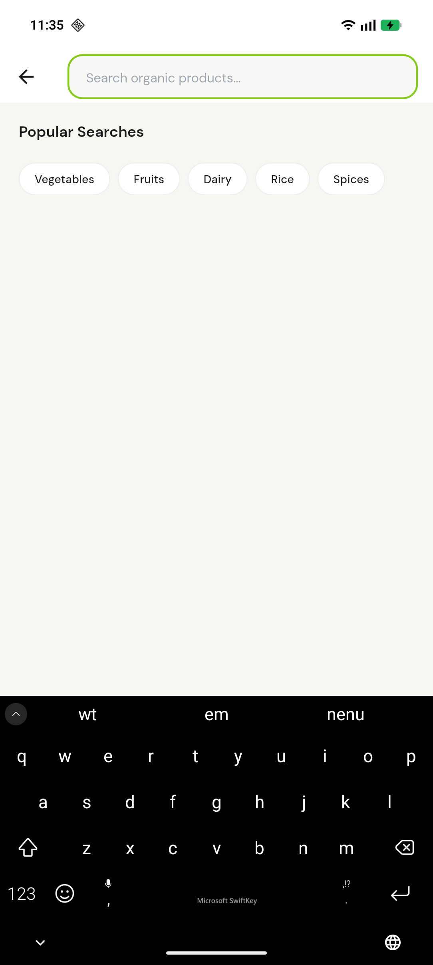

### 6. Profile & Loyalty

**Retention Loop**

The profile acts as the post-purchase hub for tracking orders and reordering favorites.

* **User Sees**: Order history, saved addresses, support.
* **Action**: Tracks live order status.

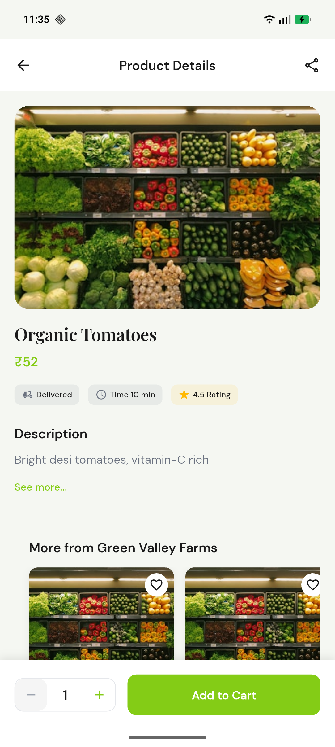

## Section 2: Admin & Vendor Web Panel (Control Flow)

_Focus: Scale, Control, and Operations_

### 1. Secure Admin Portal

**Role-Based Access**

The gateway for Admins, Staff, and Vendors. Secure authentication ensures data integrity.

* **Admin Capability**: Secure login, Role management.
* **Impact**: Protects sensitive business and user data.

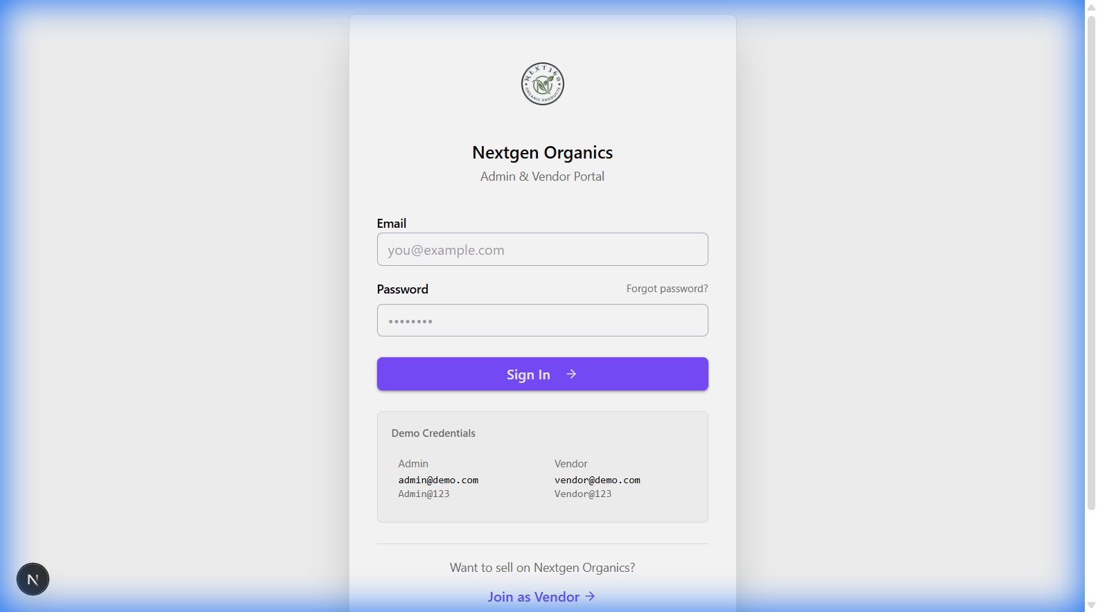

### 2. Executive Dashboard

**Bird's Eye View**

Real-time metrics on revenue, orders, and active vendors allow for data-driven decision making.

* **Admin Capability**: Monitor KPIs (Revenue, AOV, Order Volume).
* **Impact**: Immediate insight into platform health.

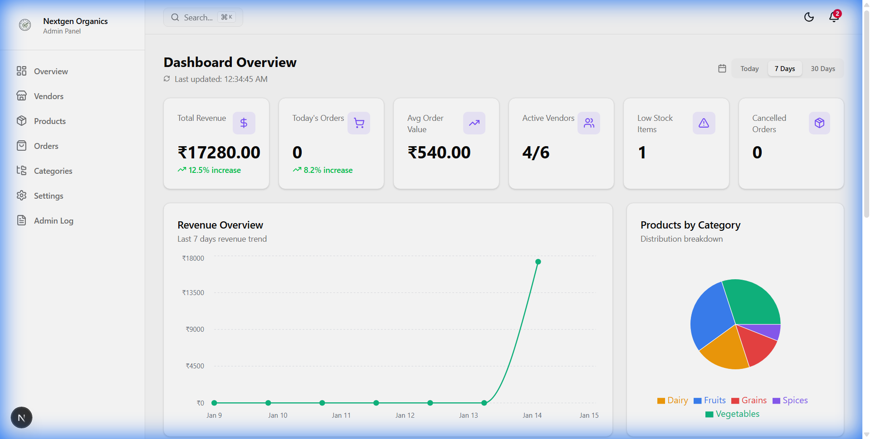

### 3. Vendor Verification & Management

**The Trust Layer**

This is where the "Verified Farm" badge comes from. Admins review documents before activating a vendor.

* **Admin Capability**: Approve/Reject vendors, View documentation.
* **Impact**: Ensures only legitimate farms sell on the app.

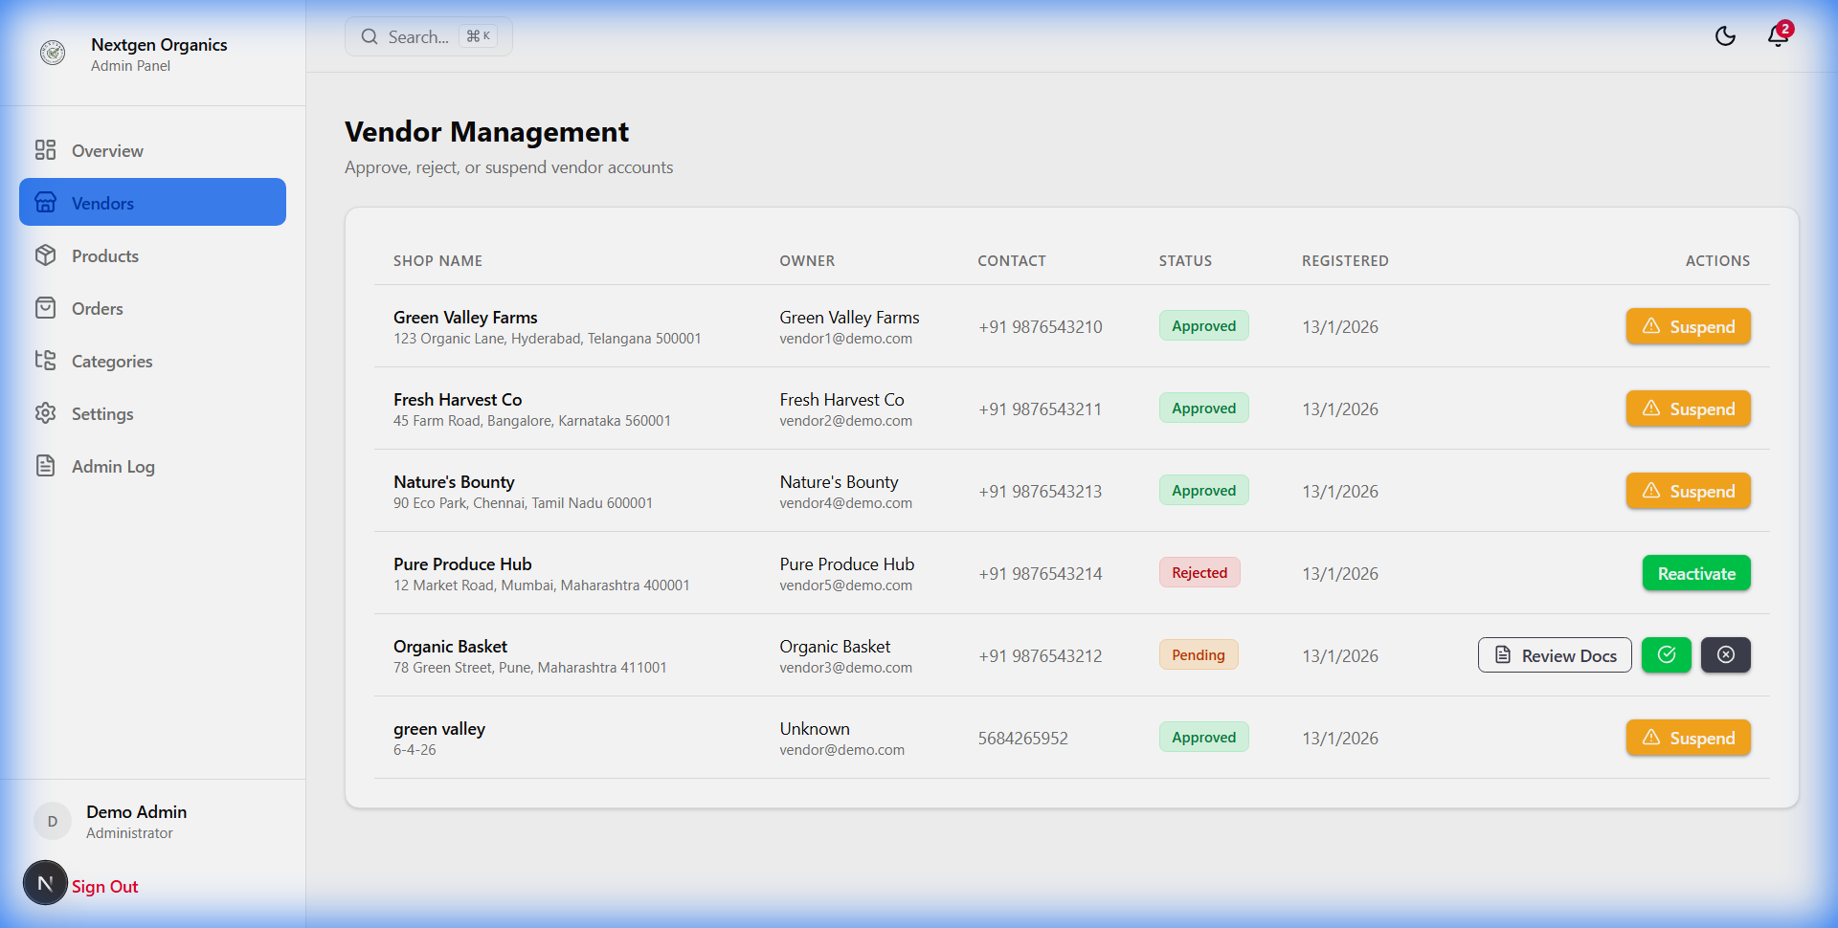

### 4. Centralized Inventory Control

**Catalog Management**

Admins oversee the entire product catalog across all vendors, establishing standard pricing and quality guidelines.

* **Admin Capability**: Monitor stock, Approve new listings, Set categories.
* **Impact**: Maintains catalog consistency and prevents stockouts.

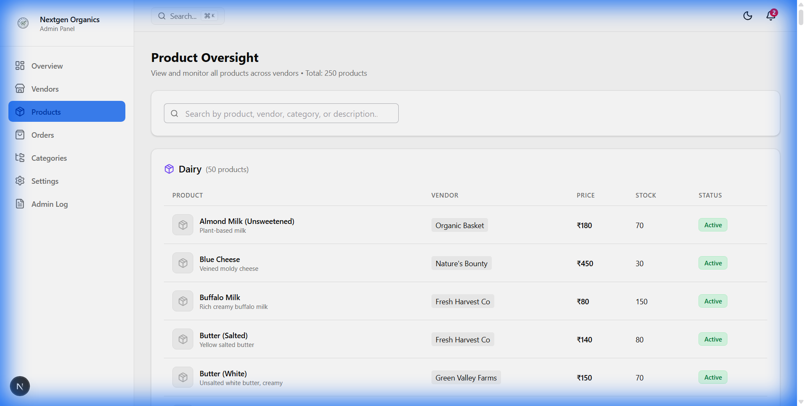

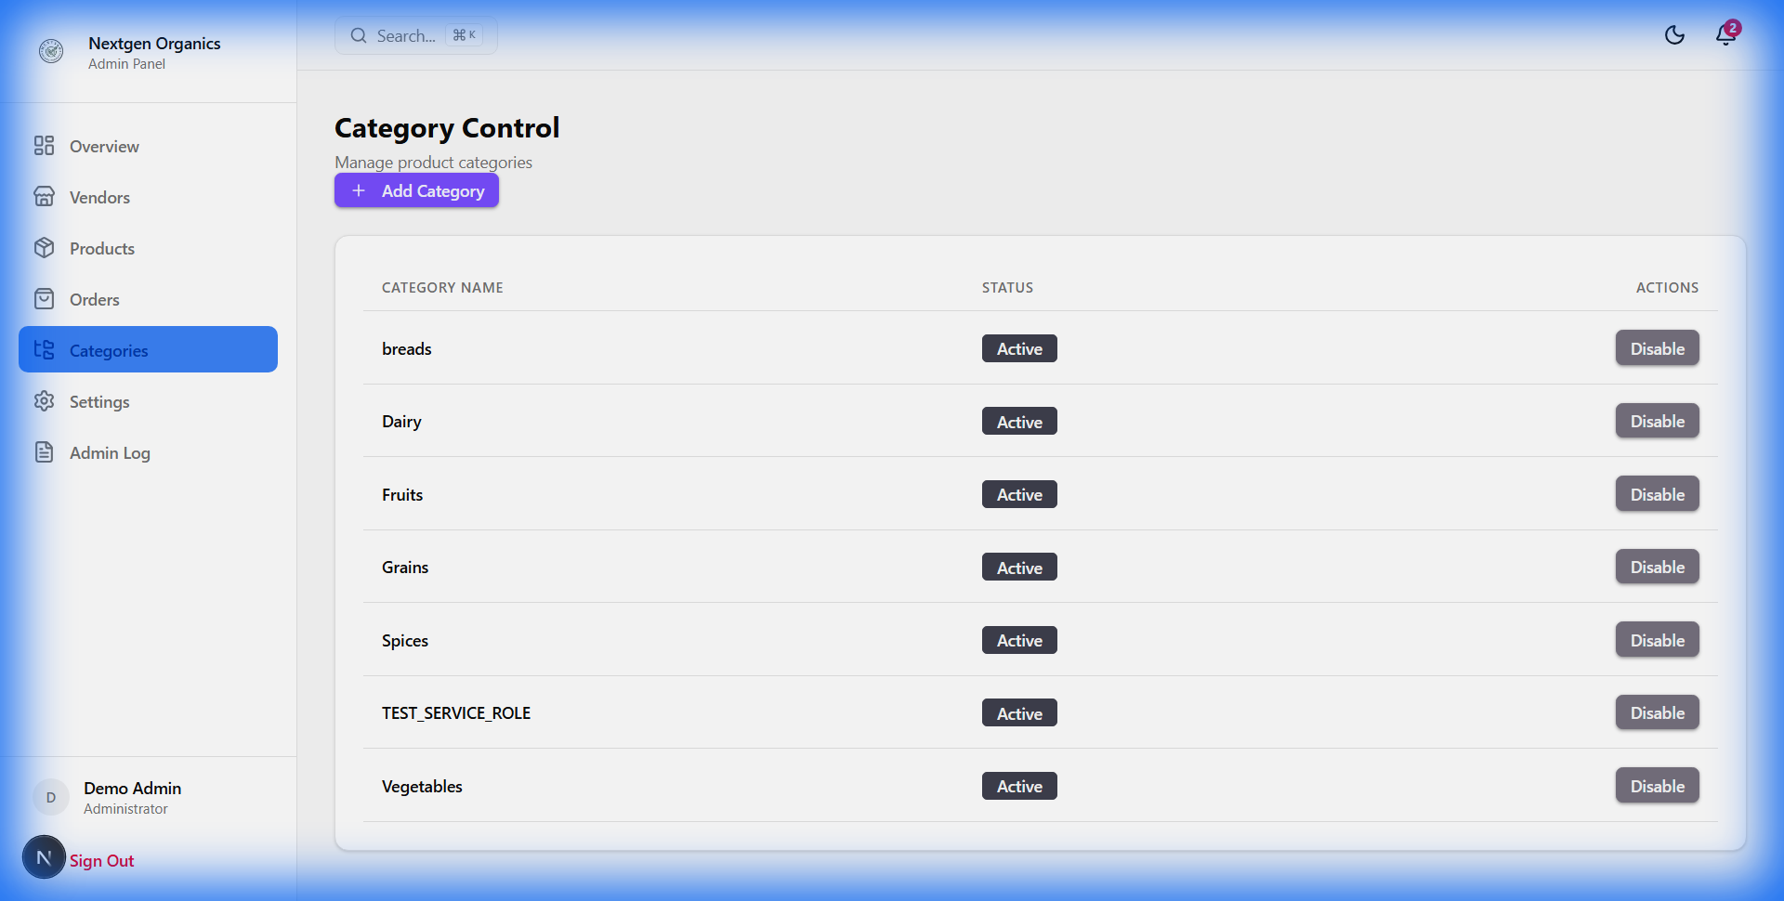

### 5. Order Fulfillment Center

**Operations Hub**

A unified view of all incoming orders, regardless of vendor. Used by support teams to resolve issues.

* **Admin Capability**: Track order lifecycle (Pending -> Delivered), Handle refunds.
* **Impact**: Ensures 100% fulfillment rate and customer satisfaction.

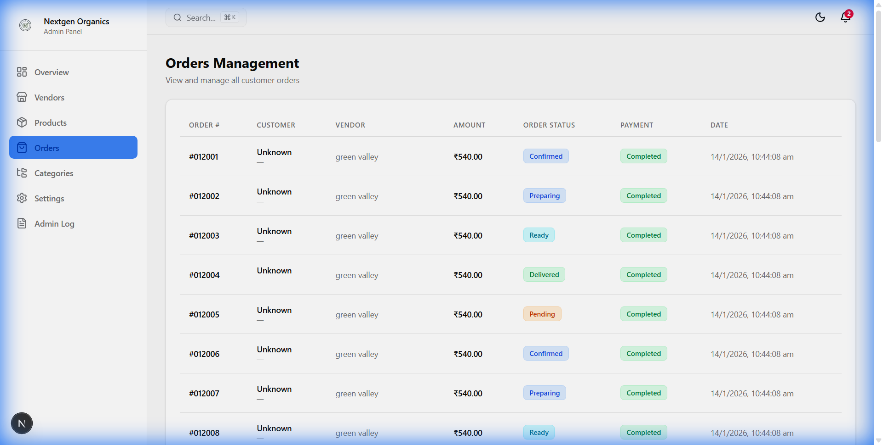

## Section 3: System Flow Explanation

**How a Farm becomes a Seller:**

1. **Application**: Vendor visits website -> "Join as Vendor" -> Uploads FSSAI/Organic Certificates.

2. **Verification**: Admin receives alert -> Manually verifies ID & Certs -> Contacts Vendor.

3. **Onboarding**: Admin approves account -> Generates Credentials -> Vendor gains Dashboard access.

4. **Go-Live**: Vendor lists products -> Admin approves listings -> Products appear instantly in Mobile App "Farms" tab.

## Section 4: Operating Model (Hub vs. Farms)

| Feature | **Hub Store (Instant)** | **Farms Mode (Direct)** |

| :------------------- | :----------------------- | :------------------------- |

| **Inventory Source** | Centralized Dark Stores | Distributed Farm Locations |

| **Delivery Speed** | < 60 Minutes | Scheduled Slots (Next Day) |

| **Stock Control** | Platform Managed | Vendor Managed |

| **User Experience** | "Shopping for Groceries" | "Shopping from a Farmer" |

| **Primary Value** | Speed & Convenience | Trust & Origin |

## Section 5: Technology Stack

* **Mobile App**: **Flutter** (Single codebase for iOS/Android). High performance, 60fps animations.
* **Admin Panel**: **Next.js (React)**. Fast, SEO-friendly, and responsive web interface.
* **Backend & Database**: **Supabase (PostgreSQL)**. Real-time updates, secure authentication, and scalable storage.
* **Infrastructure**: Cloud-native architecture ready for auto-scaling.

## Section 6: Operational Readiness

The platform is **Pilot Ready**.

* **Multi-Vendor Engine**: Successfully tested with multiple concurrent vendor accounts.
* **Centralized Control**: Admin panel provides total oversight of the marketplace.
* **Scalable Architecture**: The "Hub" model allows for rapid expansion into new cities by simply adding new inventory nodes.

_Document generated by NextGen Organics Technical Team_